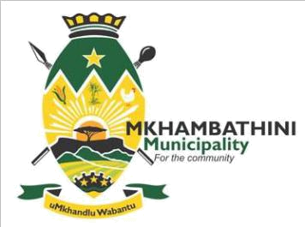

PUBLIC NOTICE: 01/2020/21

MAYORAL OUTREACH PROGRAMMES/ ROADSHOWS 2020

Led by His Worship the Honorable Mayor Cllr E Ngcongo, as part of an endeavour to ensuring sufficient service delivery, Mkhambathini Local Municipality will be conducting a Mayoral Outreach Programme. This platform is provided for all stakeholders to come and interact directly with the Municipality on issues affecting the community at large.

Amongst the key objectives, the programme seeks to: Clarify and elaborate on the programmes and plans of the Council. Enhance awareness and participation of the residents in monitoring and evaluation of the municipal plans and programs as required by the Municipal Systems Act.

Community members are herein invited to attend these Roadshows which are scheduled to take place as follows:

WARD | DATE | VENUE | TIME
Ward 1, 2 and 5 | 09 November 2020 | Nkosi Mdluli Community Hall | 10h00 am
Ward 3 and 4 | 11 November 2020 | Dukes Community Hall | 10h00 am
Ward 6 and 7 | 13 November 2020 | KwaDwengu Community Hall | 10h00 am

The IDP Representative Forum will be held on 17 November 2020 at 10h00 am - Camperdown Town Hall. For further details please contact Ms. Zandile Magini at Tel: 031 785 9370; Email: idp@mkhambathini.gov.za

uMasipala waseMkhambathini, uholwa uMhlonishwa uMeya, Cllr E Ngcongo ukuqinisekisa ukulethwa kwezidingo nqgangi emphakathini owakhele umasipala, uhlele ukuba nezimbizo (Mayoral Outreach Programmes/ Roadshows). Lemihlangano izovulela umphakathi ithuba lokuxoxisana nomasipala ngezidingonqgangi ezithinta umphakathi.

Ezinye zezinto okuzokhulunywa ngazo kulemihlangano yilezi ezilandelayo: Ukucacisa kabanzi ngezinhlelo zikamasipala. Ukuthuthukisa nokuhlomisa ngolwazi umphakathi ngendima ongayidlala ekubhekeni ukuzebenza kukamasipala uma uletha izidingo ngokulawula komthetho Municipal Systems Act.

Umphakathi wonke waseMkhambathini uyamenywa kwizimbizo ezihleleke ngalendlela elandelayo:

WARD | DATE | VENUE | TIME
Ward 1, 2 and 5 | 09 November 2020 | Nkosi Mdluli Community Hall | 10h00 am
Ward 3 and 4 | 11 November 2020 | Dukes Community Hall | 10h00 am
Ward 6 and 7 | 13 November 2020 | KwaDwengu Community Hall | 10h00 am

Ngemininingwano kungaxhunyanwa no Nkosazana Zandile Magini ku, ucingo: 031 &85 9370 or email:
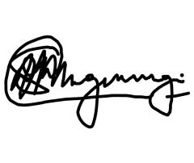
idp@mkhambathini.gov.za

MR S MNGWENGWE
MUNICIPAL MANAGER

